**THE UNIVERSITY OF DANANG**

**UNIVERSITY OF SCIENCE AND TECHNOLOGY**

**Faculty of Advanced Science and Technology**



**LABORATORY REPORT**

**INTRODUCTION TO VERY LARGE SCALE INTERGRATION IC DESIGN**

**Instructor :** Nguyen Van Cuong

**Class :** 21ECE

**Student :** Nguyen Thi Tam

*Da Nang, October 18th 2024*

Contents

I. Technical Design 2

1. Technical Objectives: 2

2. Performance Requirements: 2

3. Design Technique: 2

II. Physical Design: 6

1. Design of the Transistor for a 2-input XOR Gate: 6

2. 2-input XOR Gate: 6

3. Combining 2-input XOR Gates: 6

III. Logic Design: 6

1. Logic Equation for a 4-input XOR Gate: 6

2. Logic circuit simulation: 7

IV. Layout Design: 8

1. Layout Creation Process: 8

V. Conclusion 10

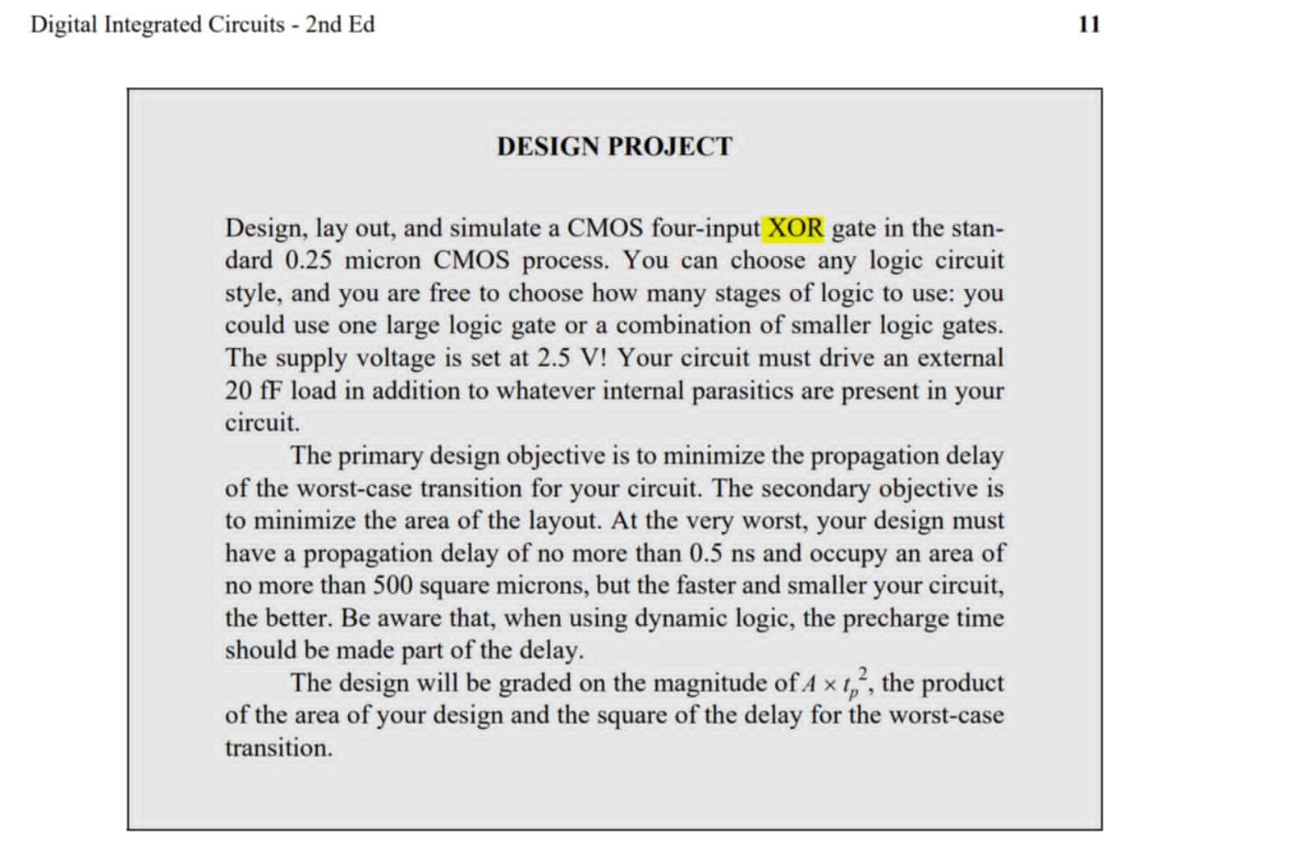

# Technical Design

## Technical Objectives:

* Design a **4-input XOR gate** using CMOS technology with a **0.25-micron process**.
* Ensure that the circuit has a propagation delay of less than **0.5 ns**.
* The **circuit area** must not exceed **500 square microns**.
* The **supply voltage** is **2.5V**, and the circuit must drive an external load of **20 fF**.

## Performance Requirements:

* Check the propagation delay and optimize the transistor sizes to meet the required delay.
* Use simulation tools to measure the circuit's parameters.

## Design Technique:

**VDD =2.5 (V) so**

From the requirement with external load = 20 fF, so:

For a supply voltage of 2.5 V, the normalized on-resistances of NMOS and PMOS transistors equal 13 kW and 31 kW, respectively. (table 3.3)

* Reqn = 13kΩ; Reqp =31kΩ

* **We must choose to obtain tp < 0.5 ns**

And

* To have propagate delay < 5ns, the size of invertor must be:

Wp <14.03 um and Wn < 5.20 um

* **Choose:**

So, Cint of of reference invertor is:

# Physical Design:

## Design of the Transistor for a 2-input XOR Gate:

* A 2-input XOR gate can be constructed using 12 transistors (6 PMOS and 6 NMOS).
* Design the pull-up network with PMOS and the pull-down network with NMOS transistors.

## 2-input XOR Gate:

* PMOS in the pull-up network is activated when the input is low, pulling the output high.
* NMOS in the pull-down network is activated when the input is high, pulling the output low.

## Combining 2-input XOR Gates:

* To create a 4-input XOR gate, combine three 2-input XOR gates. Use a 3-stage XOR structure to calculate the output of the 4-input XOR:
  + Stage 1: Z1=A⊕B, Z2=C⊕D
  + Stage 2: Y=Z1⊕Z2 ​

# Logic Design:

## Logic Equation for a 4-input XOR Gate:

Y=A ⊕ B ⊕ C ⊕ D

Or Y = (A⊕B) ⊕ (C⊕D)

* Logic diagram:

* Truth table:

|  |  |  |  |  |
| --- | --- | --- | --- | --- |
| **Input** | | | | **Output** |
| **A** | **B** | **C** | **D** | **Y** |
| **0** | **0** | **0** | **0** | **0** |
| **0** | **0** | **0** | **1** | **1** |
| **0** | **0** | **1** | **0** | **1** |
| **0** | **0** | **1** | **1** | **0** |
| **0** | **1** | **0** | **0** | **1** |
| **0** | **1** | **0** | **1** | **0** |
| **0** | **1** | **1** | **0** | **0** |
| **0** | **1** | **1** | **1** | **1** |
| **1** | **0** | **0** | **0** | **1** |
| **1** | **0** | **0** | **1** | **0** |
| **1** | **0** | **1** | **0** | **0** |
| **1** | **0** | **1** | **1** | **1** |
| **1** | **1** | **0** | **0** | **0** |
| **1** | **1** | **0** | **1** | **1** |
| **1** | **1** | **1** | **0** | **1** |
| **1** | **1** | **1** | **1** | **0** |

## Logic circuit simulation:

* The logic signal is simulated by using tool DSCH .

# Layout Design:

## Layout Creation Process:

* Physical layout of the circuit by using tool Microwind.

* Check DRC (dessign rule check).

# Conclusion

**Achieved Results**: Summarize the requirements and the outcomes of the design, such as the circuit area, propagation delay, and A×tp2A \times t_p^2A×tp2​ value.

**Comments**: Provide comments on the achieved results, potential improvements, and practical applications of this 4-input XOR gate.